Clackamas community college
Assignment Contracts
Revised: August 22, 2012
Procedural Guide
clackamas Community college
assignment contracts procedural Guide
Revision History
Version 1.1 8/09 - Included additional non-instructional assignment categories, procedures for running XCON and making changes to non-instructional assignments. Additional instructions were also included for instructors teaching for different departments.

Version 1.2 10/09 – Included change to page 3, the note near the center of the page: “All contracts should be coded to part time faculty expenditure accounts.” Please be sure you are using a position which ends in 50240, 50250, or 50265 for all contracts, regardless of the employee. Appendix B: The coding for DRP contracts has been changed to part time faculty. The contract type FT, which is not currently used, has been removed.

Version 1.3 10/09 – Added three campus organizations for the EMT Proctor and Coordinator assignments to page 6.

Version 1.4 03/10 – Added contents for making adjustments to created assignment contracts see page 4. Change OL to state you must USE when creating a FT Faculty assignment, see page 2.

Version 1.5 09/11 – Modified figure screen shots to match Datatel web version 4.3 and updated shortcuts for deleting fields to Ctrl +Alt+ D. FAQs have been updated.

Version 1.5 12/11 – Language Changes and Process changes on the following:
- Page 5, Paragraph 2 on making changes to a payable contract.
- Page 7, Title Changed from “Group 4 – Non Instructional Assignments” to “Making Group 4 and Other Professional Assignments.”
- Page 9, Step 4 – Selecting the appropriate Code for the development of FACs in FMBS
- Page 10, title Changed from “Making Changes to Group 4, Non Instructional” to “Making Changes to Group 4 and Other Professional Assignments.”

Version 1.6 08/12 – Page 1: HR now sets up the FCTY screen for paid faculty; Page 4: Added text on saving out of the screen when you’ve finished the Cntrl/Alt/D: Added text on Contract Numbers going to 10-digits you need to eliminate the “dash;” Page 9. Step 7: Added test on RSTR1, RSTR2, etc.

PLEASE NOTE: It is very important to ONLY use the CTRL +ALT+ D keys when making changes to an assignment contract. Any other form of deleting will only delete what you see and not change the assignment contract itself that is connected to payroll.

If you have any questions, concerns, or issues related to developing and/or changes for FACs, please contact one of the following people located in the Human Resource Office:
Sara Simmons at ext. 3303 - Vicki Hedges at ext. 3087 – Michele Dodgion at ext. 3092

Table of Contents
Making an Assignment Contract (Group 1 through 3) 1
Making Changes to Assignment Contracts 4
Substitutes & Docking Pay for Absence not Covered by Sick Time 5
How to View Contract Status 6
Making Group 4 and Other Professional Assignment Contracts 7
Making Changes to Group 4 or Other Professional Assignments 10
Coaching and Directors (Group 5) 11
How to View and Print a Contract 12
Appendix A – Groups 14
Appendix B – Employees, Assignment Contract (AC) Types and Memberships 15
FAQ’s P

Making an Assignment Contract (Group 1 through 3)
 Note: This procedure does not allow the faculty member to be paid. Your HR/Payroll office must still process the appropriate records. However, this process is what creates the data that is used to create the stipend (pay) for the instructor by Payroll.
Step 1. If the instructor is new, HR will set them up in Datatel. You will need to let HR know the account number for their expense and if they are paid from different accounts, what the percentage split will be.
Step 2. Access the course section you want to assign the instructor to using the Faculty Section Assignment (FASC) form.
You can access the FASC form from either the menu or by detailing from the (SECT) form.
Use standard LookUp procedures to locate the appropriate course section.
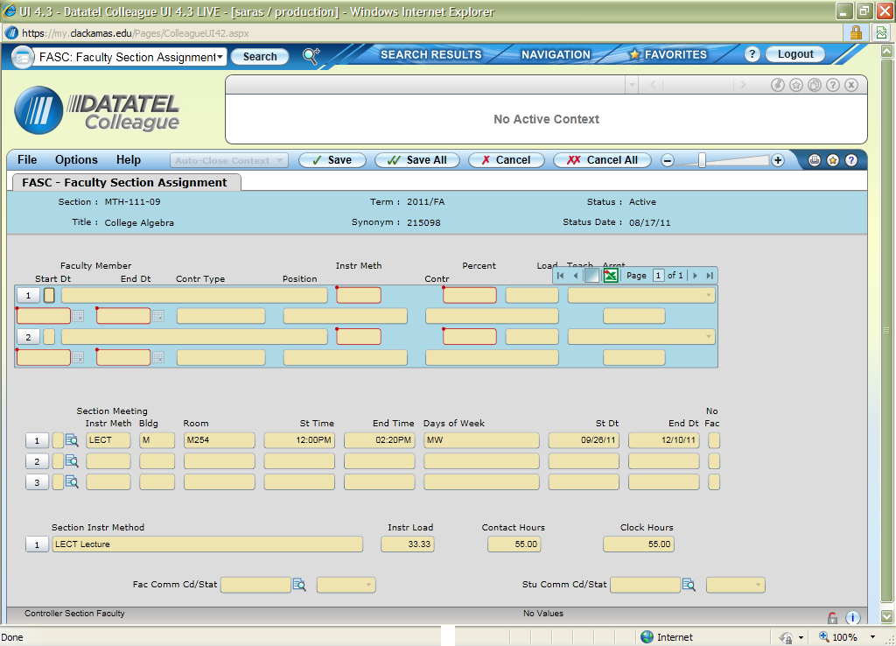Figure 1: Example of the Faculty Section Assignment (FASC) Screen
Step 3. Enter the name or ID of the faculty member you want to assign to the course section at the Faculty LookUp.
Datatel defaults the following values from the course definition (please modify dates as appropriate):
- Start/end dates ▪ Instructional method(s)
- Workload ▪ Contact hours
You can modify any of the defaulting values, if necessary. Be aware that the group designation is determined by the instructional method. Instructional methods for:
- Group 1 are LECT, CWES, HYB, SM/WK, TC and DLO
- Group 2 are LE/LA, DLOLL and HYBLL
- Group 3 are LAB, ACT, CLIN, FIELD, PE, PRAC, DLOLB, DLCWE, and HYBLB
Step 4. Enter the appropriate contract type in the Contr Type field.
PT - Part time faculty
OL – Full time faculty assignment contracts ONLY
DRP – Must use when creating a full time faculty member to be paid daily rate of pay for non-instructional assignments (only).
FT - Full time faculty - This is used to give full-time faculty an assignment without paying them (Do not use to create a payable FAC).
The contract type is not the same as the employee type. Full time faculty, for example, might have assignments using DRP or OL.
After selecting the appropriate choice, the field will populate and the cursor moves to the Position field.
At this point, Datatel defaults the load period which correspond to the start date of the course. You will usually change this field to reflect the correct number of hours to be paid on the FAC.
Example: Terms are defined per the Academic Calendar. For example winter term is 01/09/12 - 03/24/12 and spring term is 04/02/12 – 06/16/12. If the class starts 02/12/12 the default load period will be winter term.
 Note that a term/load period begins on the Sunday after finals of the previous term and ends the Saturday after finals.
If a Load Period does not default, go to the Load Period field and enter an appropriate code.
Step 5. Enter the contract position for this assignment.
You will need to do a lookup for the position (…). The “funding GL” is the account code to which the expenditure will be charged. Make sure the position is using the correct code. If the position is being paid out of more than one code, make sure the funding percentages are correct.
If there is not a position with the correct code or the percentages are incorrect, please contact HR. They will add a position with the correct code to the instructor.
 Note that all positions used to pay assignment contracts must end in 50240, 50250, or 50265, part time faculty wages. This is true regardless of the employee type – assignment contracts for full time faculty, administrators, and classifed staff are all coded to part time faculty positions.
INCLUDEPICTURE "E:\\..\\AppData\\Local\\Microsoft\\Windows\\Temporary Internet Files\\Low\\Content.IE5\\Local Settings\\Temporary Internet Files\\Local Settings\\vickidu\\Local Settings\\vickidu\\Local Settings\\Temporary Internet Files\\Content.Outlook\\Local Settings\\Temporary Internet Files\\Content.Outlook\\CUZ1GJB7\\Postions.JPG" \* MERGEFORMATINET INCLUDEPICTURE "E:\\..\\AppData\\Local\\Microsoft\\Windows\\Temporary Internet Files\\Low\\Content.IE5\\Local Settings\\Temporary Internet Files\\Local Settings\\vickidu\\Local Settings\\vickidu\\Local Settings\\Temporary Internet Files\\Content.Outlook\\Local Settings\\Temporary Internet Files\\Content.Outlook\\CUZ1GJB7\\Postions.JPG" \* MERGEFORMATINET INCLUDEPICTURE "E:\\..\\AppData\\Local\\Microsoft\\Windows\\Temporary Internet Files\\Low\\Content.IE5\\Local Settings\\Temporary Internet Files\\Local Settings\\vickidu\\Local Settings\\vickidu\\Local Settings\\Temporary Internet Files\\Content.Outlook\\Local Settings\\Temporary Internet Files\\Content.Outlook\\CUZ1GJB7\\Postions.JPG" \* MERGEFORMATINET INCLUDEPICTURE "E:\\..\\AppData\\Local\\Microsoft\\Windows\\Temporary Internet Files\\Low\\Content.IE5\\Local Settings\\Temporary Internet Files\\Local Settings\\vickidu\\Local Settings\\vickidu\\Local Settings\\Temporary Internet Files\\Content.Outlook\\Local Settings\\Temporary Internet Files\\Content.Outlook\\CUZ1GJB7\\Postions.JPG" \* MERGEFORMATINET INCLUDEPICTURE "E:\\..\\AppData\\Local\\Microsoft\\Windows\\Temporary Internet Files\\Low\\Content.IE5\\Local Settings\\Temporary Internet Files\\Local Settings\\vickidu\\Local Settings\\vickidu\\Local Settings\\Temporary Internet Files\\Content.Outlook\\Local Settings\\Temporary Internet Files\\Content.Outlook\\CUZ1GJB7\\Postions.JPG" \* MERGEFORMATINET INCLUDEPICTURE "E:\\..\\AppData\\Local\\Microsoft\\Windows\\Temporary Internet Files\\Low\\Content.IE5\\Local Settings\\Temporary Internet Files\\Local Settings\\vickidu\\Local Settings\\vickidu\\Local Settings\\Temporary Internet Files\\Content.Outlook\\Local Settings\\Temporary Internet Files\\Content.Outlook\\CUZ1GJB7\\Postions.JPG" \* MERGEFORMATINET INCLUDEPICTURE "F:\\..\\AppData\\Local\\Microsoft\\Windows\\Temporary Internet Files\\Low\\Content.IE5\\Local Settings\\Temporary Internet Files\\Local Settings\\vickidu\\Local Settings\\vickidu\\Local Settings\\Temporary Internet Files\\Content.Outlook\\Local Settings\\Temporary Internet Files\\Content.Outlook\\CUZ1GJB7\\Postions.JPG" \* MERGEFORMATINET INCLUDEPICTURE "F:\\..\\AppData\\Local\\Microsoft\\Windows\\Temporary Internet Files\\Low\\Content.IE5\\Local Settings\\Temporary Internet Files\\Local Settings\\vickidu\\Local Settings\\vickidu\\Local Settings\\Temporary Internet Files\\Content.Outlook\\Local Settings\\Temporary Internet Files\\Content.Outlook\\CUZ1GJB7\\Postions.JPG" \* MERGEFORMATINET INCLUDEPICTURE "E:\\..\\AppData\\Local\\Microsoft\\Windows\\Temporary Internet Files\\Low\\Content.IE5\\Local Settings\\Temporary Internet Files\\Local Settings\\vickidu\\Local Settings\\vickidu\\Local Settings\\Temporary Internet Files\\Content.Outlook\\Local Settings\\Temporary Internet Files\\Content.Outlook\\CUZ1GJB7\\Postions.JPG" \* MERGEFORMATINET INCLUDEPICTURE "E:\\..\\AppData\\Local\\Microsoft\\Windows\\Temporary Internet Files\\Low\\Content.IE5\\Local Settings\\Temporary Internet Files\\Local Settings\\vickidu\\Local Settings\\vickidu\\Local Settings\\Temporary Internet Files\\Content.Outlook\\Local Settings\\Temporary Internet Files\\Content.Outlook\\CUZ1GJB7\\Postions.JPG" \* MERGEFORMATINET 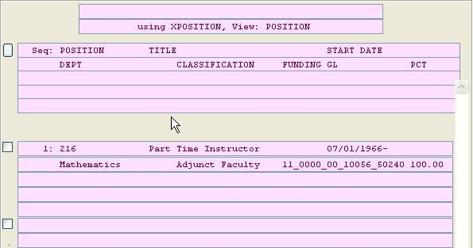Figure 2: Example of the Position LookUp Screen
After selecting the appropriate choice, the field will populate and the cursor moves to the Contr field.
Step 6. Fill in the load field with the number of contact hours the instructor is getting paid for. This should correlate with the contact hours listed at the bottom of the screen. Be aware that this field is used only for pay.
Step 7. You do NOT need to enter anything in the Contr field as long as Contract Type, Position, Load and Load Period are filled in.
When you update the record, the contract ID is displayed briefly when you save out of the screen before it closes. The contract ID will contain a department code followed by a number. If your instructor teaches for more than one department, record this contract ID and use it to print only assignments for this faculty within your department. If you miss the contract ID you can go back into FASC to view it.
Step 8. Save the course section record.
Datatel has now created a pending contract and has calculated pay. This information can now be viewed by running the XCON report.
 Note that it is still possible to make changes. See section “Making Changes to Assignment Contracts” below.

Making Changes to Assignment Contracts
It is okay to make as many changes as you want while the contract is in the PE (pending) status. However, if you have already created a new assignment through FASC, you will need to follow these steps:
Step 1. Access FASC
Step 2. When adding hours to an existing contract, note the contract number, then delete the values using either Ctrl+Alt+D (do not use the delete function button or delete whole group) in fields "Contr Type," "Position," “Contract Number,” and "Load Period," and note if you need to adjust dates. This will remove the current assignment. You must save out of the screen and then reenter to proceed with the changes.
Step 3. After making your other changes, reenter the Contract Type, Position and Load Period (only the number of hours to be paid, do not include the hours from the original contract). In the Contract Number field, type the number in as previously noted, but add the letter (A, B, or C) on the end. This will create a new contract.
The reason for doing this is because the calculation for pay has already been computed and deleting and reentering this information recalculates the pay.
When subtracting hours from an existing contract, if it hasn’t been made payable, use the process noted above, but use the same contract number (do not add an A, B, or C. Then you must send an email to payroll with employee’s name, contract number, which class (if more then one) amount of hours the contract should be so they can make sure it is changed. Note: If the contract number exceeds 10 digits, eliminate the “dash.”
If it is a payable contract, contact payroll to make the change and they will instruct you as to when you can change it in the system.
Step 4. You can verify everything is correct by running XCON (in the HR module).
When there are changes made after a contract is in the PA (Paid) status, a warning message will appear letting you know that you are making changes to a contract that is in the PA status.
After the change has been made, the contract will be changed to an AM (Amended) status.
If you are making changes to a contract that puts it in an amended status, contact Payroll via email ASAP and alert them to these changes. 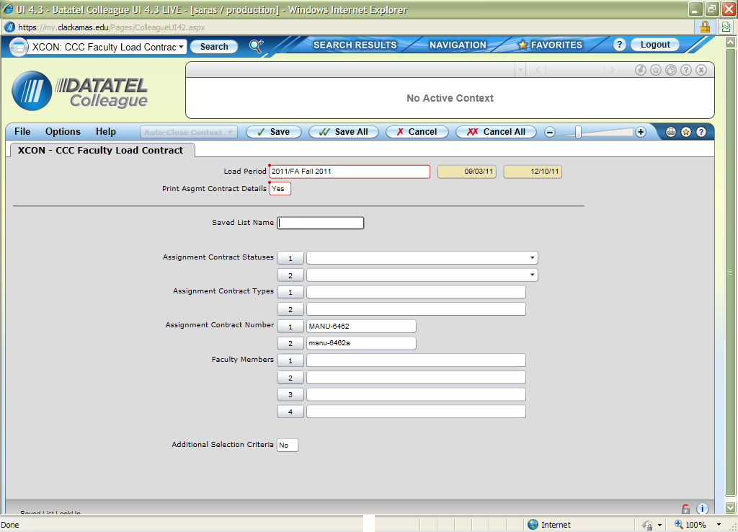
Figure 3: Example of XCON

Substitutes & Docking Pay for Absence not Covered by Sick Time
With group 1 through 3, if an instructor misses time that isn’t covered by their sick time, the original assignment contract needs to be changed. This is similar to making changes to previous assignments. Contact the HR office to verify if sick leave applies.
If the assignment has been made payable, the original assignment needs to be deleted and a new one created with the revised load using the same contract number (Note: If the system does not allow you to use the same contract number, you must inform payroll of the old and new number to prevent double payment). Print the contract for the new assignment with XCON, and note on the contract the original contract number that this is modifying. The contract then needs to be taken to Payroll. Let Payroll know as soon as possible that this process is/has happened.
If the assignment hasn’t been made payable, delete the original assignment, create the modified assignment, and process normally.
If a substitute needs to be paid for covering a portion of the assignment, add them as an instructor to the course section in FASC and create an assignment contract for the time period and the load taught as described in the section “Making an Assignment Contract (Group 1 through 3)”.

How to View Contract Status
The RFAL report has four criteria that you can mix and match to get the data you want, the assignment contract status, type, contract number or the faculty member(s).
Step 1. Access the RFAL screen in the HR module.
Step 2. Use the look up field to populate the load period field for the timeframe you want to report on.
Step 3. Populate the “Print Asgmt Contract Details” with an “Y”.
Step 4. If you want to use status as a criteria, in the Assignment Contract Statuses field enter the statuses that you want to view. You can also do this for assignment contract types.
 Note: When running this report by status only, you will receive information on every department.
Step 5. If you only want to view contracts for a particular department, enter each contract number in the field labeled Assignment Contract Number. Department is determined by the instructor’s position. It is possible to have multiple contracts within one department, if the position is set up as a separate department. To view the contract number, go into FASC on an assignment which has been created and see what is populated in the Contr field.
Step 6. If you want to use the faculty members as a criteria, in the faculty member’s field enter the faculty that you would like to view.
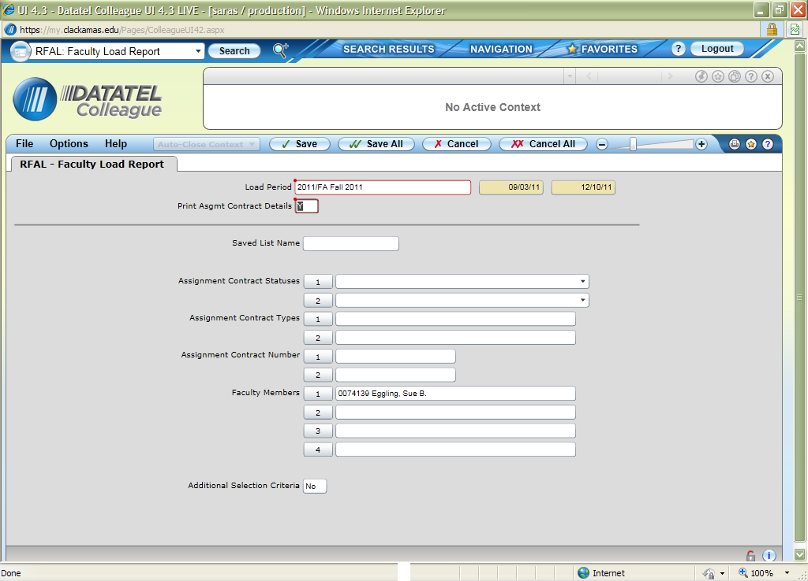
Figure 4: Example of RFAL Parameter Screen

Making Group 4 and other professional Assignment contracts
In FMBS the items once located in Group 4, per the bargaining agreement, have been split between Group 4 and Other Professional Assignments (OP). When developing an assignment in FMBS it is important that you use the appropriate code below. Please do not group items within codes because this may affect the calculation of the assignment. You do not have to create separate FACs only choose the appropriate codes for the FAC.
Group OP | Acronyms |  |  | Group 4 |  |  | Acronyms
ACCBE | Challenge Exam, AC
ACCD | Curriculum Development, AC |  |  | ACCOU |  |  | Counseling
ACCPL | Credit for Prior Learning, AC |  |  | ACLIB |  |  | Library Services
ACCUR | Curriculum Committee, AC |  |  | ACPCS |  |  | Practicum Supervision
ACDS | Distance Learning Com, AC |  |  | ACPM |  |  | Project Management
ACDIV | Diversity Committee, AC
ACEMC | Emt Coordinator, AC
ACEMF | Emt Proctor Full Day, AC
ACEMH | Emt Proctor Half Day, AC
ACINF | Information Resources Com, AC
ACINS | Instrct. Stand & Pract Com, AC
ACMET | Meetings, AC
ACOH | Office Hours, AC
ACOTH | Other Noninstructional, AC
ACPCC | Prep, Class Cancelled, AC
ACSEC | Campus Security Committee, AC
ACSTF | Staff Development Committee, AC
ACUSE | Campus Use & Development Com, AC

Step 1. Access the Faculty Memberships screen (FMBS).
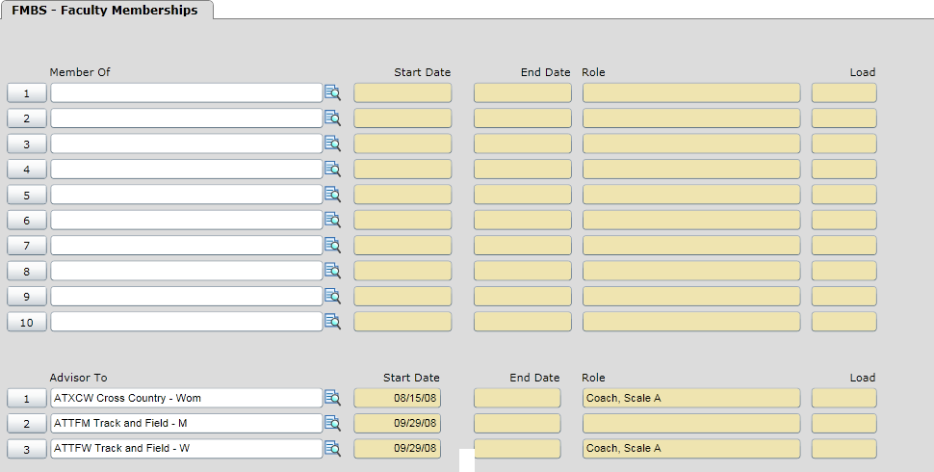
Figure 5: Example of FMBS Screen
Step 2. Enter the appropriate faculty member.
Step 3. In the Member Of field enter "..."
Step 4. Select the appropriate Organization code per Code table stated above. In the example used here for office hours, ACOH (Assignment Contract Office Hours) is chosen.
Step 5. When doing this the Faculty Membership Detail (XFMD) screen will appear.
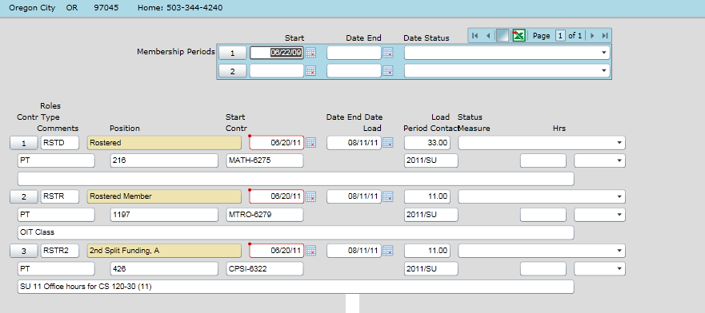
Figure 6: Example of XFMD Screen
Step 6. In the Membership Periods Start Date field, if there is not already a date there, enter the first date they are working (do not enter an end date.)
Step 7. In the Roles field enter "..." and select the option RSTR (Rostered Member). Note when developing a contract in the same term for the same employee you will need to use RSTR1, RSTR2, etc.
Step 8. Enter the start and end dates of the load they are teaching for the office hours. Be sure the start date is in the correct term/load period you want it assigned to.
Step 9. Enter the total number of contact hours they are getting paid for in the "Load" field. One office hour a week for a full term would be a load of 11. Two office hours a week for a full term would be a load of 22, etc.
Step 10. In the "Contr Type" enter "..." and select the appropriate option.
Step 11. In the position field enter "..." and select the appropriate position.
Step 12. In the load period enter "..." and select the appropriate term.
Step 13. In the comments field you can add some descriptive text. This is optional except for the Campus Organization of Other Non-instructional (ACOTH). The comments are mandatory in that case. Also, once you create the comments you can’t change or erase them without deleting the whole group.
Step 14. When you save out of XFMD, the contract number will populate. For faculty who teach in more than one department, you will need this number in order to print only assignments for the faculty members that are tied to your department.
Step 15. Click the “Save” button twice.
Step 16. If this is done after the contract is in the PA status, refer to “Making Changes to Non-Instructional Assignments” and complete steps 1-4.
Step 17. If the instructor already has office hours assigned and needs additional hours, if it’s for the same time period and position use Ctrl + Alt +D to erase the contract type, position, contract and load period and re-enter the info with the updated load. If the instructor is to be paid from a different position (different GL account) for the same time period (an instructor whose office hours are paid by two departments because they teach in both,) use the RSTR1- RSTR3 role and set the instructor up following the above steps 1 through 13.

Making Changes to Group 4 or Other Professional Assignments
This process is similar to making changes on Instructional Assignments with FASC. It is okay to make as many changes as you want while the contract is in the PE (pending) status. However, if you have already created a non-instructional assignment through XFMD, you will need to follow these steps:
Step 1. Access FMBS and then XFMD for the appropriate Campus Organization.
Step 2. Delete the values in fields "Contr Type," "Position," “Contract,” and "Load Period." You will need to use Ctrl + D to delete these values. This will remove the current assignment.
Step 3. After making your other changes, reenter the Contract Type, Position and Load Period.
Step 4. You can verify everything is correct by running XCON (in the HR module).
When there are changes made after a contract is in the PA (Paid) status, a warning message will appear letting you know that you are making changes to a contract that is in the payable (PA) status.
After the change has been made, the contract will be changed to an AM (Amended) status.
If you are making changes to a contract that puts it in an amended status, contact Payroll via email ASAP and alert them to these changes.
Coaching and Directors (Group 5)
This process is very similar to Non-Instructional Assignments, Group 4.
Step 1. Access FMBS.
Step 2. Enter the appropriate faculty member.
Step 3. In the Advisor To field enter "..."
Step 4. Select the correct Campus Organization. (Say ATBB for Baseball.)
Step 5. The FAOA screen will appear.
Figure 7: Example of FMBS using the Advisor Section

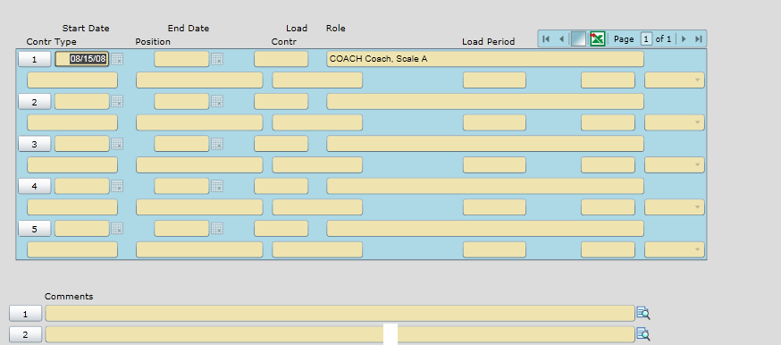
Figure 8: Example of FAOA Screen
Step 6. Enter the start and end date of the assignment. (Be sure that the start date is within the term/load period you want it assigned to.)
Step 7. Enter any load hours that would apply to dues work load. The load does not affect the amount paid to the employee.
Step 8. Do a lookup in the role field and select the appropriate role. Notice in the description the pay scale of the group 5 role.
Step 9. Fill in the Contract Type, Position and Load period and save out of the screen.
Step 10. For faculty who teach in more than one department, note the contract number. You will need this number in order to print only assignments tied to your department.

How to view and print a contract
The XCON report has four criteria that you can mix and match to get the data you want, the assignment contract status, type, contract number or the faculty member(s).
Step 1. Access the XCON screen in the HR module.
Step 2. Use the look up field to populate the load period field for the timeframe you want to report on.
Step 3. Populate the “Print Asgmt Contract Details” with an “Y”.
Step 4. If you want to use status as a criteria, in the Assignment Contract Statuses field enter the statuses that you want to view. You can also do this for assignment contract types.
 Warning: When running this report by status only, you will receive information on every department.
Step 5. If you only want to print contracts for particular department, enter each contract number here. If you do not specify a contract number for a faculty working in more than one department, a separate contract will print for each department. Department is determined by the instructor’s position. It is possible to have multiple contracts within one department, if the position is set up as a separate department. To view the contract number, go into FASC on an assignment which has been created and see what is populated in the Contr field.
Step 6. If you want to use the faculty members as a criteria, in the faculty member’s field enter the faculty that you would like to view.

THANKS!!

Appendix A – Groups
 | Level
 | 1 | 2 | 3 | 4
Group 1:
Lecture courses
Group 2:
Lecture/lab courses
Group 3:
Lab courses
Group 4:
Clinical Supervision, Counselors, Librarians
Other Professional Assignments: Challenge Exams, Curriculum Development, office hours, meetings, and other non-instructional time.
Group 5:
Student Activities Schedule
Scale A
Head Coaches: Baseball, Softball, Soccer, Volleyball, Wrestling, Men’s' & Women’s’ Basketball and Track
Directors: Drama, Jazz Ensemble, Forensics
Scale B
Director: Swing Choir
Scale C
Head Coach: Cross Country
Intramurals-Asst. Coaches: Baseball, Softball, Soccer, Volleyball, Wrestling, Men’s & Women’s Basketball and Track
Scale D
Director: Pep Band

Appendix B – Employees, Assignment Contract (AC) Types and Memberships

EMPLOYEES, ASSIGNMENT CONTRACT (AC) TYPES, AND MEMBERSHIPS
Type of  Employee | Work | Notes | AC  Type | Account
FT faculty | Non-instructional work beyond the individual’s 175-day contract. | Per Bargaining Agreement | DRP | Faculty, part time  50240-50265-50250
FT faculty | Instructional assignments in excess of the individual’s normal teaching load. |  | OL | Faculty, part time  50240-50265
PT faculty | All work (groups 1-5) | Never use for FT assignment contracts | PT | Faculty, part time  50240-50265
Classified | Courses (groups 1-3) |  | PT | Faculty, part time  50240-50265
Administration | Courses (groups 1-3) |  | PT | Faculty, part time  50240-50265

FAQ’s
- Will instructors be paid by credit or clock hours or something else?
Salary Groups 1-4 and C are paid by contact hours entered into the load field on FASC. Group 5 is a specific amount for all work performed.
- How do we show office hours? Substitutes? Special projects?
FMBS and XFMD will be used for office hours and possibly for special projects. Substitutes will be paid as described in the section titled “Substitutes & Docking Pay for Absence Not Covered by Sick Time”.
- Who will input the info on the instructor's teaching load?
The person who creates the course section will input the contact hours for the instructor’s load.
- What if an instructor is paid out of more than one account?
They will have to be assigned a position with the proper funding from all the applicable accounts.
- Will there be a window for people to input changes? If there is a change, who will make it?
The assignment can be modified given the processes outlined in the sections “Making Changes to Assignment Contracts” and “Making Changes to Non-Instructional Assignments”. These changes can be done up until Payroll runs CLPS. At the point Payroll runs CLPS a payable stipend is created. If the assignment is modified after that, putting it into an amended status, Payroll will have to be notified so they can change/reissue the stipend.
Either the Dean’s Assistants or the Department Secretaries can make the change.
- What about classes who have instructors attached but are never paid (ex: ACC classes)?
Enter the instructor on FASC but don’t link the assignment to make an actual contract.
- What about classes that have more than one instructor?
Enter them on the FASC screen with the load split as necessary amongst the Faculty to cover the contact hours for the class.
- When choosing a position, do you only get one choice?
Yes, you may only choose one position number per assignment, so if you are in need of a position with more then one funding source, please contact Human Resources.
- Can you have Dept. Chair as instructor and not get paid?
Yes. You can have an instructor with zero load or with assignment type of FT.
- If FT faculty is in overload and then the section is cancelled, what is the process?
Delete the overload (OL) assignment and send an email to payroll.
- When we build sections, do we need to put in FT faculty loads?
It would be beneficial to input load for FT faculty, but not necessary for now.
- Will we need signatures?
You only need to obtain signatures from the department chair and/or dean. Not from the instructor. Please provide a copy for the instructor’s records.

DLOLL and HYBLL are new instructional methods indicating lecture/lab versions of HYB and DLO respectively.
DLOLB, DLCWE, and HYBLB are new instructional methods indicating lab versions of DLO, CWES and HYB respectively.
The reason for doing this is because the calculation for pay has already been computed and deleting and reentering this information recalculates the pay.

